Outrage Room Edits – Round two

Homepage:

Use Color Code #C2161C Red (Please replace all items in red to this color)

Use the font from the logo (if possible.) Make the “Smash and Relieve Your Stress” more impactful like the logo (Use this text throughout the site for the main headings)



Screenshot 1 (below): Please change this section to look like the SECOND Screenshot. Please remove: “Most Popular Flights….” and insert “**More ways to experience the Outrage Room**”.

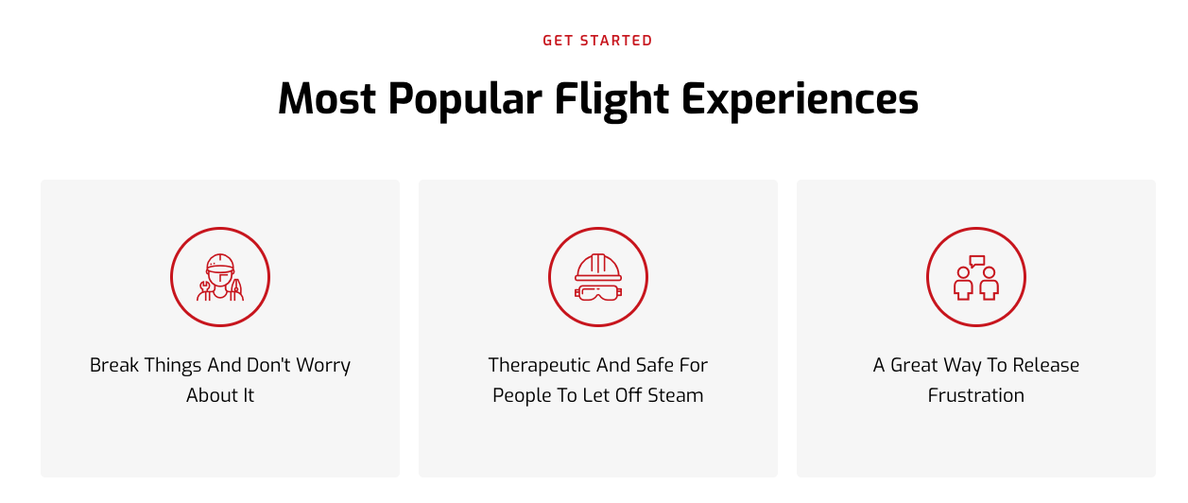

Second Screenshot (below):

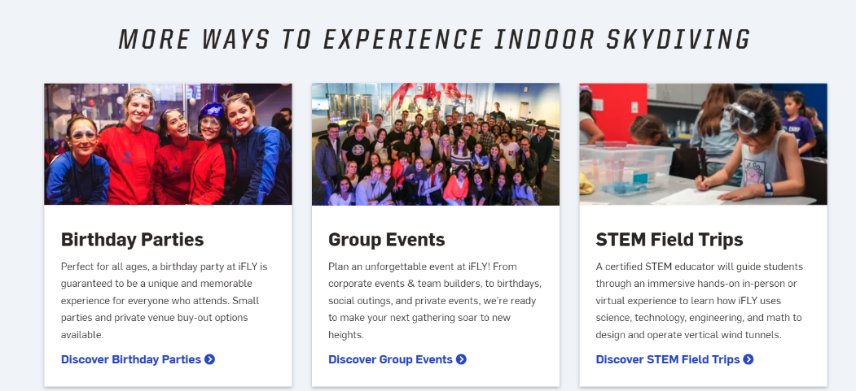

Please make the background in a darker shade of Gray (see arrow)

Rename the boxes in this new section to:

**Special Events**

*Insert this text for this box:* “Perfect for all ages! Your Outrage Room special event is guaranteed to be a unique and memorable experience for everyone who attends. Some of our special events have included: Birthday Parties, Grieving the loss of a loved one, Wedding receptions, Community Popups, and much more.”

*Insert this text as the link at the bottom of the box* (see screenshot above to understand what I am asking here: “**Discover Special Events**”

**Group Events**

*Insert this text for this box:* “Plan an unforgettable event for you organization. From corporate events, team building, and Dynamic professional developmental opportunities, we are ready to make your next event Outrageous”.

*Insert this text as the link at the bottom of the box* (see screenshot above to understand what I am asking here: “**Discover Group Events**”

**School Events**

*Insert this text for this box:* Our Rageologist will guide students through an unforgettable experience used to help release frustration, improve retention, and provide a chance to leave stress behind. This experience turns school-related tension into a memorable and enjoyable experience for everyone and through our many services offered provide creative and innovative expression with art.

*Insert this text as the link at the bottom of the box:*(see screenshot above to understand what I am asking here: “**Discover School Events**”

When someone clicks on each one of the boxes, it should open up to a page that looks like this link:

<https://www.iflyworld.com/plan-your-event/birthdays/> Make a separate page for: Special Events, Group Events, and School Events

NOTE: You do not have to create these pages to look exactly like the link. Instead, you will only create each page to look like the header of that page (from the link) and the screenshot below:

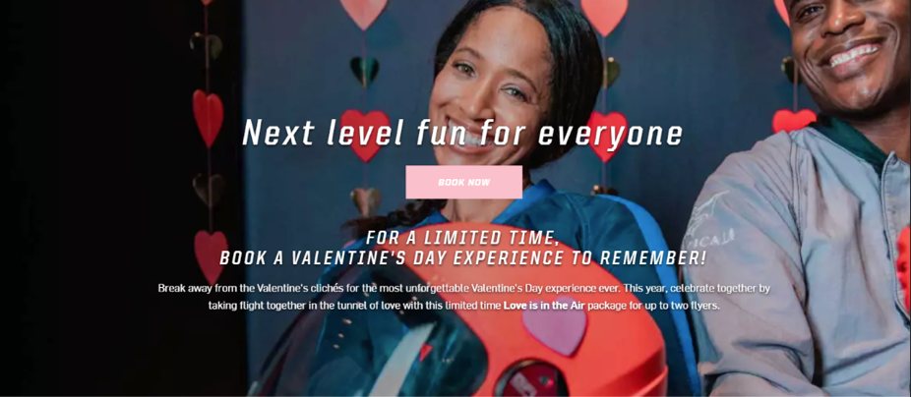

So place the screenshot underneath the new header on that page with the Book Now Button and the following text:

**Special Event page text:**

*Main Text:* “What Happens at your special event? “

*Subtext:* “When it comes to birthday parties, bachelor parties, divorce parties, grief events etc! The Outrage Room is equipped to deliver a unique and memorable experience for you and your guest. All we need are a few details about the event you have in mind, and we’ll take care of the rest.”

**Group Event page text:**

*Main Text:* “An Experience to Remember Forever. “

*Subtext:* “No matter what you’re celebrating with friends, family, or co-workers, The Outrage Room brings people together.”

**School Event page text:**

*Main Text:* “The Most Enriching School Event. Ever!“

*Subtext:* “Our School Events are a thrilling, immersive adventure perfect for all types of organizations. Witch flexible packages and scheduling for your organization, The Outrage Room is a unique on campus experience. Some of the groups that can benefit from the services provide by The Outrage Room include:

Colleges/universities, Public/private schools, Scouts BSA, Girl Scouts, Youth groups, Summer camps , JROTC groups, School clubs, Homeschools, Fostering agencies, and Behavior health organizations

**On Homepage:**

Remove About Section (see screenshot):

“Our Programs” Section:

Make the four boxes wider (close to full screen) Use the Footer image behind this section

Box 1: Remove “Birthday parties”. Then remove “Give the gift of flying” and insert: “**The Rage Room**”

*Then insert the following subtext:* Our mobile rage room is a fun and safe environment where you can make art out of anger and stress, it can be used in a variety of ways. People use them at weddings, birthday parties, Schools, company events and the list goes on. If you want a to provide an awesome experience or really give people something to rave about, try our mobile rage room. It's an experience you don’t want to miss!

Box 2: Remove “Birthday parties”. Then remove “Advanced excel boot camp” and insert: “**Splatter Painting**”

*Then insert the following subtext:* Splatter painting is a form of abstract art where paint dances like a chaotic symphony creating fun and unpredictable patterns. Splatter painting is great for creative expression, and emotional release. Let's level up your next event with our mobile paint studio.

Box 3: Remove “Birthday parties”. Then remove “Advanced excel boot camp” and insert: “**Car Smashing Package:**”

*Then insert the following subtext:* Car smashing is a kinetic therapy that shatters stress into a pure freedom. This cathartic activity involves the use of tools such as sledgehammers and bats to create a masterpiece of automotive demolition. Great for teambuilding, wellness events, and those dealing with unspoken stress; car smashing is a must have experience and it can be for anyone looking to take an event to the next level.

Box 4: Remove “Birthday parties”. Then remove “Advanced excel boot camp” and insert: “**Teambuilding & Professional Development**”

*Then insert the following subtext:* Unlock the door to your employee's professional potential and step into a realm where growth is not just a destination but a thrilling journey. We offer a wide range of professional development opportunities for organizations such as leadership education, managing difficult conversations, time management, emotional intelligence and much more. One of our most popular programs is Everything **DiSC** (embed a link that takes them to this program [What is Disc](https://www.everythingdisc.com/what-is-disc/) ) which is used to support organizations in helping individuals understand and improve their communication styles, work dynamics and interpersonal relationships with in the work place.  Take advantage of our tailored development programs to address your organization's specific needs by scheduling a needs assessment.

**On Homepage:**

Remove the “How it Works” section.

**Footer:**

Correct Spelling in Footer. At the very bottom of the Home page, it says: **The Outerrage Room**

 (this is spelled incorrectly should be “**The Outrage Room**”).

Remove Careers

 Chance Privacy Policy to “Cancelation Policy”

 Change Ifly news to: “Rage News.”

 Change Rage and Splatter to: “Rage, Splatter, & Car Smashing “

Under “Professional Development’ in Footer, please list the following:

* Leadership Development
* Professional Development
* Team Building

Under “Get in Touch”, in Footer, please do the following:

Remove the email address and insert the email address behind the “contact us” so that it emails the [admin@theoutrageroom.com](mailto:admin@theoutrageroom.com)

Please remove “Atlanta, Macon, etc”. Can you insert a picture of a map that shows the southeastern part of the United States? The map should show the following states: Georgia, Florida, Alabama, Tennessee, South Carolina

**Note: These states are connected to each other**

Create an About Us Page

**In footer, where it says “About us”** it should take us to another page that has the following content on it (see below). This page should also like the 4 programs section with links to book and take to the program specific page.

* This is the about us content that should be used where ever we have a section that says about us.
  + The Outrage Room is a mobile rage room created to enrich the lives of others by providing a safe environment to release stress. Our model focuses on student retention and employee reengagement by using non-conventional ways to help students and employees destress and have fun. We proudly offer:  rage room, splatter painting, and car smashing services to our customers as well as  provide professional developmental programs for corporate, non-profit, and governmental organizations to aid in their organizational development and employee success.

FAQ’s Page.

**Rage Room Section:**

***Change description to*:** “Our mobile rage room is a fun and safe environment where you can make art out of anger and stress, it can be used in a variety of ways. People use them at weddings, birthday parties, Schools, company events and the list goes on. If you want a to provide an awesome experience or really give people something to rave about, try our mobile rage room. It's an experience you don’t want to miss!”

* Are you mobile or do you have a brick-and-mortar location?
  + The Outrage Room is a Georgia based company that provides mobile services to the following states: Georgia, Florida, Alabama, Tennesse, and South Carolina.
* Can the mobile unit come to my company?
  + Yes, we can go just about anywhere. Many corporations use our services to help reduce burn out and stress within their employees during wellness weeks and during stressful work periods. Unlike any other rage room, The Outrage Room staff consist of individuals who are well versed in facilitating teambuilding activities, as well as soft skill and leadership developmental opportunities that can help build comradery and transform your staff through dynamic training.
* Can the mobile unit come to our college campus**?  (This question is on here twice (please remove one of them)**
  + Absolutely! Our organization was formed to help improve student retention at the university level. The Outrage Room has been a hit on college campuses. Many use our services during wellness week, move ins, and during finals week.
* What is The Outrage Room (Move this above the first Question)
  + The Outrage Room is a mobile rage room created to enrich the lives of others by providing a safe environment to release stress. We proudly offer:  rage room, splatter painting, and car smashing services to our customers as well as provide professional developmental programs for corporate, non-profit, and governmental organizations to aid in their organizational development and employee success.
* Are rage rooms safe?
  + Safety is our number one priority! We fit each participant with appropriate protections and give a safety tutorial before the session starts.
* Is there an age limit?
* Can I just show up by myself or with my group. (Remove or hide since we are not moving forward with the Brick and Mortar)
* Do I need to bring anything with me to smash?
  + Just your inner warrior! All equipment will be provided unless you purchase a Bring your Own Breakables (BYOB) package. In that case you will need to bring your own things to break.
* What do I need to wear? (Keep the same, no edits)
* If I bring my own breakable, what can I bring? (Keep the same, no edits)
* What happens if I am running late to my session? (Remove or hide since we are not moving forward with the Brick and Mortar)
* Is your location wheelchair assessable? (Remove or hide since we are not moving forward with the Brick and Mortar)
* Do you allow birthday and private parties?
  + Absolutely, all individuals participating in the services must be 8 years and older.

**Splatter Painting Section:**

***Change description to*:** “Splatter painting is a form of abstract art where paint dances like a chaotic symphony creating fun and unpredictable patterns. Splatter painting is great for creative expression, and emotional release. Let's level up your next event with our mobile paint studio.”

* What is splatter painting? (Keep the same, no edits)
* How exactly does this work? (Keep the same, no edits)
* Is there an age requirement (Keep the same, no edits)
* What should we wear? (Keep the same, no edits)
* What is included with the reservation? **(Remove)**
* Are food and drinks allowed? (Keep the same, no edits)
* Do you allow birthday and private parties?
  + Absolutely, all individuals participating in the services must be 8 years and older.

**Add “Car Smashing” Section: (**Questions are in **BOLD** and the answers are below it)

***Change description to*: “**Car smashing is a kinetic therapy that shatters stress into a pure freedom. This cathartic activity involves the use of tools such as sledgehammers and bats to create a masterpiece of automotive demolition. Great for teambuilding, wellness events, and those dealing with unspoken stress; car smashing is a must have experience and it can be for anyone looking to take an event to the next level.”

**What is mobile car smashing?**

Mobile car smashing involves bringing the experience of smashing objects, including cars, to a location of your choice using a mobile setup.

**How does mobile car smashing work?**

It can work however you want it to work, traditionally our team brings a decommissioned car to your event for participants to smash using various tools.   Participants then have the opportunity to release stress by smashing or spray painting the car, within that setup.

**Is mobile car smashing safe?**

Safety measures are in place, including protective gear and controlled environments. Trained staff can oversee the experience to ensure participant safety. Or if wanting to facilitate your own event you may, however you must adhere to the safety measures provided.

**What types of cars are used in mobile car smashing?**

Depending on the service, decommissioned or specially prepared vehicles may be used, ensuring safety while providing a satisfying smashing experience.

 **Can anyone participate in mobile car smashing?**

Participation requirements may vary, but participants often need to adhere to age restrictions, sign waivers, and follow safety guidelines to ensure a secure experience.

**How can I book a mobile car smashing experience?**

You can book directly on our website. There are add-ons that you can include in your package as well.

**Are there any restrictions on where mobile car smashing can take place?**

Must be done on an open flat surface. Can be done on grass or concrete.

**What is the purpose of mobile car smashing in a rage room?**

The primary purpose is to provide a cathartic and stress-relieving experience for participants by offering a controlled environment for smashing objects, including cars, as a form of fun release.

**Add “Professional Development” Section: (**Questions are in **BOLD** and the answers are below it)

***Change description to*: “**Unlock the door to your employee's professional potential and step into a realm where growth is not just a destination but a thrilling journey. We offer a wide range of professional development opportunities for organizations such as leadership education, managing difficult conversations, emotional intelligence and much more. One of our most popular programs is Everything **DiSC** (embed a link that takes them to this program <https://www.everythingdisc.com/what-is-disc/> ) which is used to support organizations in helping individuals understand and improve their communication styles, work dynamics and interpersonal relationships with in the work place.  Take advantage of our tailored development programs to address your organization's specific needs by scheduling a needs assessment.

**What does your professional development programs do?**

Our programs focus on enhancing the skills, knowledge, and abilities of individuals within organizations through training, coaching, and educational programs.

**How can we sign up?**

You will need to schedule a needs assessment meeting and our training team will send you an invite to discuss your specific needs.

**I work for a governmental agency, and we are required to have these types of services go out for bidding. Are you able to bid?**

Absolutely! Currently we are approved vendors for the state of Georgia, city of Atlanta, and Fulton County. We can complete any necessary document to become an approved vendor with your organization.

**I have a large organization and want all our employees to go through training, how does this work?**

We offer virtual instructor led training and professional development programs to provide flexibility to large organizations. Within our needs assessment we will work to determine the amount and frequency of the training. We collaborate with you to determine what the training agreement looks like.

**Can we participate in multiple programs?**

Absolutely! The Outrage Room can pair our professional development or team building program with splatter painting, car smashing, or the rage room.

**Can you work with remote teams?**

Yes, we offer virtual training solutions, making it possible to engage with remote teams and individuals globally.

**How long does a typical professional development program last?**

The duration varies based on the specific program or training, ranging from short workshops to extended leadership development programs that span several months.